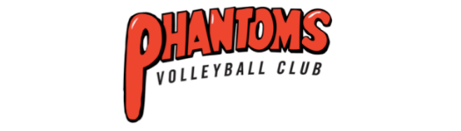
2026 Club Person of the Year - Nomination Form
Please check the box below for the award nomination:
☐ Player ☐ Coach/Official ☐ Administrator

Please complete the nominee and nominator information below:
Nominee
Name:
Position/role within the club:

Detailed outline of the nominee’s eligibility for the award (min 250 words):

Evidence of the nominee’s eligibility for the award (min 250 words):

Nominator Details
Name:
Phone: Email:
Signature:

Completed nomination forms are to be returned to:
Phantoms Volleyball Club
Email: info@phantomsvolleyball.com.au

